Chapter 19, Solution 23.

(a)
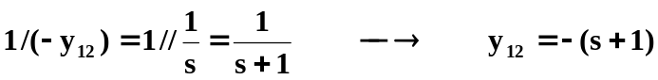

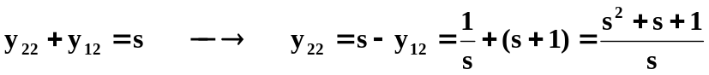

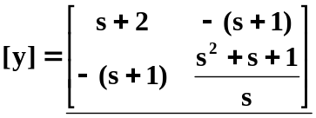
(b) Consider the network below.

I₁ I₂
1

+ + +
[y]

V_{s} V₁ V₂ 2
- - -

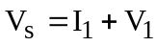 (1)

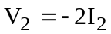 (2)

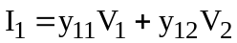 (3)

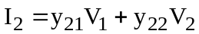 (4)

From (1) and (3)

(5)

From (2) and (4),

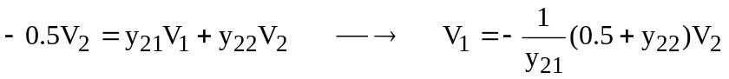 (6)

Substituting (6) into (5),

